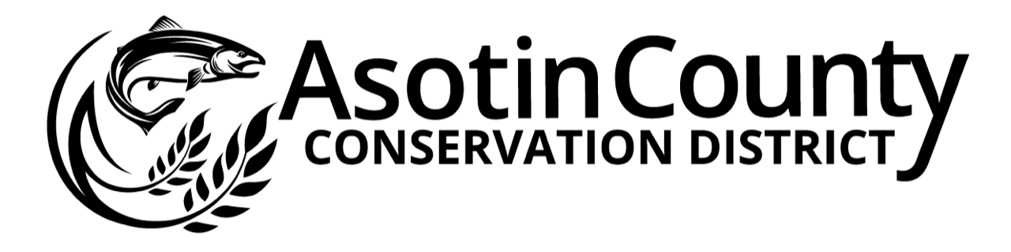

Position Description

Title: Resource Technician Introduction:
The duties of this position are to address natural resource issues by working cooperatively with private landowners, district staff, and state, local, and federal agencies to implement Best Management Practices (BMP’s), implement conservation plans, provide technical assistance, and collect and analyze natural resource data. This position’s primary responsibility will be coordinating the District’s Bighorn Sheep Health Outreach Program and Non-Commercial Small Farm Program. Funding for this position is subject to availability and successful attainment of grant money.

Essential Duties & Responsibilities:

- Provide technical assistance to domestic sheep and goat owners including swab testing for the M. ovi bacteria.
- Lead outreach efforts including interacting with the general public, landowners, answering public inquiries, scheduling testing and outreach meetings, and following up with testing results.
- Maintain testing and outreach data, including recording, summarizing, and tabulating field data utilizing electronic devices, software programs, and paper forms.
- Restrains domestic sheep and goats and assists in sample collection.
- Conducts data entry in ArcGIS, Microsoft Access, and Excel.
- Develops outreach materials and content including maps, infographics, posters, and videos.
- Prepares quarterly report for stakeholders and advisory group.
- Participates in stakeholder and advisory group meetings.
- Coordinate and implement district projects.
- Contact interested landowners & assist them with developing individual plans to best protect and improve natural resources on their property.
- Provide individual landowners with technical assistance including providing information and recommendations for voluntary implementation.
- Work cooperatively with landowners and coordinating agencies to effectively implement grant program requirements.
- Coordinate between landowner and other agencies for technical assistance.
- Prepare permit applications, environmental compliance, and other documents necessary for conservations projects. Work with funding sources, partners, archaeologists, and landowners to ensure cultural resource surveys are completed.
- Promote the cost-share program and assist landowners with cost-share applications.
- Work with NRCS, partners and landowners to develop quality resource plans.
- Provide periodic project inspection during the life of the projects as directed by District Coordinators
- Participate in outreach activities such as workshops and tours.
- Attend workshops, training sessions and meetings within and outside of the district as directed by the District Coordinators. Occasional overnight travel may be involved.
- Prepare or assist with the preparation of project reporting.
- Assist with identifying grant opportunities and writing grant applications as assigned.
- Occasionally operate equipment as required for fieldwork according to safety requirements and district policy.
- Perform other duties as assigned by District Coordinators & District Board of Supervisors.

Required Knowledge & Skills:

- Must be able to effectively communicate verbally and in writing with a diversity of cooperators, co-workers, and others.
- Must be self-motivated, able to work independently and in groups, work efficiently and honestly.
- Must have demonstrable experience working positively and successfully with individuals one-on-one and in group settings.
- Ability and desire to motivate individuals to adopt and implement resource management practices on their property. This may include educational speaking in front of public groups, organizations, or clubs, as well as one on one interaction
- Organizational, report and informational writing, and research skills are required.
- Ability to coordinate multiple projects and timelines with flexible scheduling
- Computer literacy (word processing, spreadsheets, and database management) is required at an intermediate level or higher
- Ability to organize and plan own schedule of activities related to work goals
- Ability to maintain accurate records regarding time-keeping and authorized expenses
- Ability to work closely, cooperatively, and in a non-confrontational manner with others in a public office environment
- Must be able to physically perform the tasks of the job in the field by traversing uneven ground in varied weather conditions and occasionally carrying up to 50 pounds of equipment and/or materials
- Ability to operate ATV/UTV (if necessary) in a safe and prudent manner and to attend
and successfully complete ATV/UTV Rider Course.
- Use current technology to conduct all conservation work activities.
- Must have, or be able to obtain, and maintain a valid driver’s License. ACCD will conduct a driving record review.

Preferred Knowledge & Skills:

- Agriculture background and experience.
- A two-year degree with preferred course work in one or more of the following areas: agricultural sciences, soils, water quality, biology, general sciences, environmental sciences, fish and wildlife management, natural resource management, engineering, or a related discipline. Knowledge of a broad range of soil and water conservation principles, techniques, methods, and practices to apply and install conservation systems, which involve complex and diverse land uses.
- Knowledge and understanding of water quality standards and criteria for watershed health, riparian restoration, and ecosystem function.
- Knowledge and understanding of livestock management, grazing practices, and riparian management.
- Knowledge and experience of domestic animal husbandry.
- Knowledge and understanding of agricultural and cropping systems
- Knowledge and understanding in riparian function and restoration processes to improve water quality and aquatic habitat.
- Knowledge of plant communities and ecology.
- Knowledge and experience using Global Positioning System (GPS) devices to collect point, line, and area information and downloading data to a computer system for further analysis.
- Ability to import data, analyze data sets, and develop maps and other graphical depictions of conservation values and plans using mapping software such as ArcGIS.
- Knowledge and skill in surveying and identifying soils and/or hydrologic processes
- Ability to effectively use a variety of tools to collect, disseminate, and record natural resource data.
- Experience conducting biological field work and data collection, in sometimes challenging conditions.
- Experience providing outreach/education to the public.

This position’s compensation will start at $17.00 per hour DOQ/DOE. This position will receive vacation and sick leave, medical, vision, and dental insurance, and retirement benefits as outlined in the employee appointment letter. Terms of compensation and benefits are set by the position appointment letter and may be amended at any time by the Board of Supervisors.

